

Critical Design Review - Electrical
INNEX-1 Rover - Innova UoL
University of Leicester, UK Lunabotics Team

Team Name | Innova UoL
Project Name | INNEX-1 Rover
Sub-Team | Electrical
Document Title | CDR - Electrical
University | University of Leicester
Department | School of Engineering
Date of Submission | 12/03/2026
Author(s) | Enio Mecaj
Authorised by | Tire Joseph
Version | 2.2

Summary
The Electrical Critical Design Review (CDR) details an electrical architecture centred around a dual-domain power system. By physically isolating the motive domain, powered by a 22.2V 6S 8000mAh LiPo battery, from the compute domain, powered by a 14.8V 4S 5000mAh LiPo battery, the design prevents high-torque voltage drop from browning out the NVIDIA Jetson and sensors. Safety and reliability are heavily prioritised; the system features a 250A E-Stop (push-break, 80V DC rated) that severs motive power while keeping the compute rail and telemetry feeds alive and uses a passive 95dB low-voltage buzzer rather than an active BMS to prevent automated shutdown during heavy mechanical manoeuvres. Furthermore, by enforcing an operational rule that prevents driving and excavating at the same time, the absolute peak current is strictly capped at 40A, giving the main battery a safety factor of 3. This electrical hardware is packaged inside a 5mm polycarbonate enclosure using a single-direction airflow strategy that pulls cool air over the compute modules before exhausting heat from the motor drivers. Finally, the entire system is mapped with load-calculated wire gauges and is backed by a £1,218 electrical budget.

Summary 0
1 Final schematic 4
1.1 Compute Domain Schematic 4
1.2 Power Domain Schematic 4
1.3 Low-Voltage Warning Batteries 5
1.4 Connector Types 5
2 Harness design 18
2.1 Bus Voltage 18
2.2 Wiring Topology: 20
2.2.1 Main Power Domain: 20
2.2.2 Compute Power Domain 21
2.3 Peak Current Calculations 21
2.4 Component Connection Map 21
2.4.1 Main Battery → ANL Fuse → Arming Switch → Power Meter → E-STOP → PDB 21
2.4.2 Power wiring – PDB to Sabertooth 22
2.4.3 Signal wiring – Sabertooth to Jetson 23
2.4.4 Motor Wiring – Sabertooth to GR-WM4-V3 motors 24
2.4.5 Encoder Wiring – GR-QM4-V3 to Jetson 24
2.4.6 Power Wiring – PDB to Cytron 25
2.4.7 Signal Wiring - Cytron to Jetson 25
2.4.8 Actuator Wiring – Cytron to Actuator 26
2.4.9 Power Wiring – PDB to BLD-510B BLDC Controller 27
2.4.10 Signal Wiring – BLD-510B BLDC to Jetson 27
2.4.11 Excavation Motor Wiring – BLDC to Excavation Motor 28
2.5 Complete Wiring Gauge 29
3 Power budget 30
3.1 Drivetrain and excavation subsystem: 31
3.1.1 Scenario A: Driving & Navigating 31
3.1.2 Scenario B: Excavation (Rover is stationary) 31
3.2 Computational subsystem: 31
3.3 Battery C-Rating Numerical Justification 31
3.4 Secondary Compute Battery (14.8V) C-Rating Justification 32
3.5 Battery Runtime Calculation 32
4 Physical integration 33
4.1 Overview 33
4.2 Electrical Layout Architecture 33
4.3 Mechanical Packaging 34
4.4 Thermal Management Strategy 34
4.5 Electrical Safety Considerations 34
4.6 CAD Integration & System Validation 35
4.7 Evidence 35
5 E-STOP & safety chain 36
5.1 Back EMF 36
5.2 Bench Test 37
5.3 E-stop requirements 37
5.4 E-Stop Schematic 38
6 Procurement locked 38
6.1 Main parts BOM 38
6.2 Cost 39
6.3 Alternative List 40

Table of Figures
Figure 1 Compute Domain Schematic 4
Figure 2 Power Domain Schematic 5
Figure 3 Power Domain Diagram 19
Figure 4 Compute Domain Diagram 20
Figure 5 CAD Files for Electrical Box 33
Figure 6 Exhaust and Cooling Diagram 34
Figure 7 E- Stop and Wiring Schematic 36

Final schematic

Compute Domain Schematic
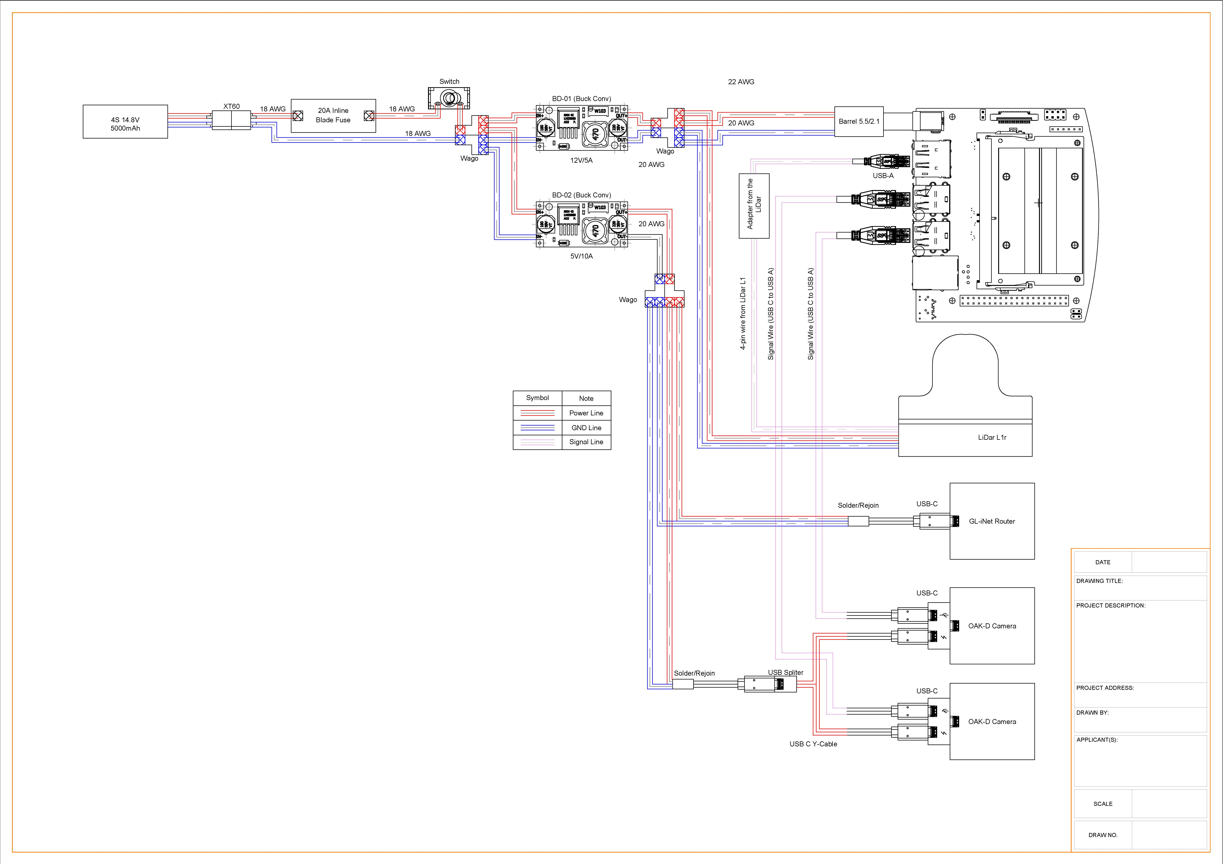
Figure 1 Compute Domain Schematic

Power Domain Schematic
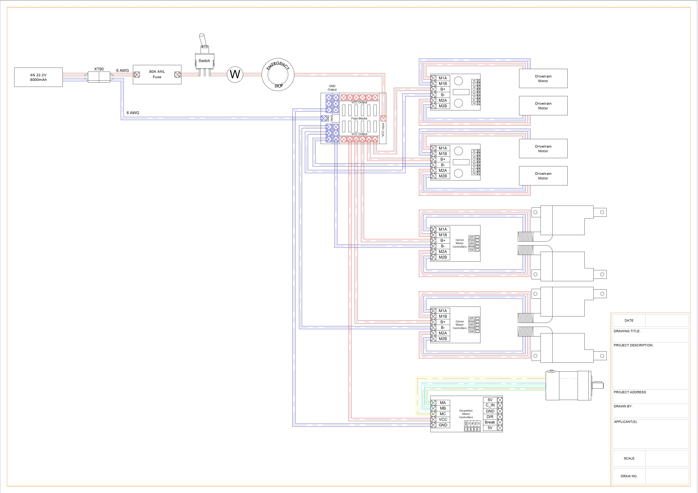
Figure 2 Power Domain Schematic

Low-Voltage Warning Batteries
The architecture uses a passive low-voltage warning system instead of an active onboard Battery Management System (BMS) to manage battery safety during high-load movement/excavation operations without sacrificing motive power. When high-amperage robotic drivetrains come into contact with obstacles, they often experience brief voltage drops. Unwanted system brownouts and lost autonomy cycles would result from an in-line BMS interpreting these brief drops as critical faults and physically cutting power.

The motive and compute batteries' balance leads are directly connected to 1S-8S LiPo buzzer alarms in order to stop this. These devices independently track the voltages of each cell in real time. A 95dB audible alarm is set off if a single cell falls below the 3.4V safe threshold. By warning operators and scrutineers about a draining cell while keeping the power circuit closed so the operator can complete the current manoeuvre before starting a safe manual shutdown, this passive audio-telemetry meets the competition LiPo safety requirements.
1-8 S Buzzer Low Voltage Alarm Indicator Lipo Batteries : https://www.amazon.co.uk/zalati-Battery-Testers-Voltage-Reminders/dp/B0CJV4RW2T?source=ps-sl-shoppingads-lpcontext&ref_=fplfs&psc=1&smid=A1DHSBK7H5KQMH

Connector Types

Power Domain Connector Types & Connections
The power domain is supplies by the main battery which is a Turngy 6S LiPo battery (XT90 connector). All the drivetrain motors, actuator motors and the excavation motor and their controllers draw from this rail via the power distribution board (PDB). The safety chain runs – Main battery (+) → 40A inline fuse → Arming switch → E-STOP → PDB.
MAIN BATTERY CHAIN:
Circuit ID | From | To | AWG | Connector Type | Fuse | Notes
PW-01 | Main Battery (+) | Inline fuse | 10 AWG | XT90 Anti-spark (battery end) | 40A ANL | Red wire. XT90 anti-spark connector at the battery terminal.
PW-02 | ANL fuse out | Arming switch L1 | 10 AWG | Ring terminal on switch lugs |  | Red wire. Ring terminal crimped to arming switch lugs. Inline ANL fuse output.
PW-03 | Power meter +OUT | E-STOP terminal A | 10 AWG | High-Current ring terminal on E-STOP input. |  | After power meter.
PW-04 | E-STOP terminal B | PDB +IN | PDB +IN | Direct wire into PDB positive rail |  | E-STOP output into PDB positive bus. Final link before PDB
PW-GND | Main Battery (-) | PDB -IN | PDB -IN | Direct wire into PDB negative rail |  | Black wire. Ground BYPASSES E-STOP – direct battery negative to PDB ground bus.
POWER WIRING: PDB to Sabertooth motor controllers
Circuit ID | From | To | AWG | Connector Type | Fuse | Notes
MC-01 + | PDB + Rail | Sabertooth #1 B+ | 10 AWG | Ring Terminal on Sabertooth screw terminal | None | Fuse holder within 50mm of PDB output. Red wire into Sabertooth B+ screw terminal.
MC-01 - | PDB – Rail | Sabertooth #1 B- | 10 AWG | Screw Terminal (direct) |  | Black wire into Sabertooth B- screw terminal. No fuse on return path.
MC-02 + | PDB + Rail | Sabertooth #2 B+ | 10 AWG | Ring terminal on sabretooth screw terminal | None | Separate fuse per controller. Fuse holder within 50mm of PDB output.
MC-02 - | PDB – Rail | Sabertooth #2 B- | 10 AWG | Direct wire into PDB negative rail |  | Black wire. Ground return for sabretooth #2
SIGNAL WIRING: Sabertooth motor controllers to Jetson Orin Nano
Signal | From (Sabertooth pin) | To (Jetson Orin Nano) | AWG | Connector Type | Fuse | Notes
S1 (Serial) | S1 Terminal | Teensy 4.1 UART TX | 24 AWG | Dupont/JST (logic level signal wire) |  | Simplified serial (one wire per controller). DIP switches set to Serial mode. 9600 baud default.
0V (GND) | 0V Terminal | Common GND Bus | 24 AWG | Dupont/JST (signal ground) |  | MUST share ground with Jetson for correct signal reference. Essential for signal integrity.

MOTOR WIRING: Sabertooth to GR-WM4-V3
Circuit ID | From | To | AWG | Connector Type | Fuse | Notes
MT-01 | Sabertooth #1 M1A/M1B | Drive motor 1 +/- | 14AWG | Screw Terminal (sabretooth) → GR-WM4 6P Latch Bullet Connector. |  | 10A/channel (software limited via Sabertooth). Screw terminal exit from Sabertooth, transitioning to 6P latch bullet on GR-WM4 harness.
MT-02 | Sabertooth #1 M2A/M2B | Drive motor 2 +/- | 14AWG | Screw Terminal (sabretooth) → GR-WM4 6P Latch Bullet Connector. |  | 10A/channel (software limited via Sabertooth). Screw terminal exit from Sabertooth, transitioning to 6P latch bullet on GR-WM4 harness.
MT-01 | Sabertooth #2 M1A/M1B | Drive motor 3 +/- | 14AWG | Screw Terminal (sabretooth) → GR-WM4 6P Latch Bullet Connector. |  | 10A/channel (software limited via Sabertooth). Screw terminal exit from Sabertooth, transitioning to 6P latch bullet on GR-WM4 harness.
MT-01 | Sabertooth #2 M2A/M2B | Drive motor 4 +/- | 14AWG | Screw Terminal (sabretooth) → GR-WM4 6P Latch Bullet Connector. |  | 10A/channel (software limited via Sabertooth). Screw terminal exit from Sabertooth, transitioning to 6P latch bullet on GR-WM4 harness.
ENCODER WIRING: GR-QM4-V3 Encoders to Jetson
Wire | Colour | From | AWG | Connector Type | Fuse | Notes
VCC | Red | Teensy 4.1 3.3V | 26AWG | WAGO 221-413 (shared 5V supply) |  | 5V encoder power. <10mA. Can share supply with WAGO 221-413 splitter.
GND | Black | Common GND Bus | 26AWG | WAGO/Dupont (signal ground) |  | Teensy GND. Keep encoder GND on separate WAGO output from motor controller GNDs to avoid noise coupling.
CH A | Blue | Teensy 4.1 GPIO | 26AWG | Dupont/JST |  | Twist CH A & CH B together. Route away from 14 AWG motor wires to prevent interference.
CH B | Yellow | Teensy 4.1 GPIO | 26AWG | Dupont/JST |  | Quadrature pair with CH A. Route twisted with CH A.
VCC | Red | Teensy 4.1 3.3V | 26AWG | WAGO 221-413 (4th encoder) |  | 5V encoder power. <10mA. Can share supply with WAGO 221-413 splitter.
POWER WIRING: PDB to Cytron Actuator motor controller
Circuit ID | From | To | AWG | Connector type | Fuse | Notes
ACT-01 + | PDB + Rail | Cytron #1 B+ | 10 AWG | Ring Terminal on Cytron Screw Terminal | 15A Inline | Fuse holder within 50mm of PDB output. Red wire into Cytron B+ screw terminal.
ACT-01 - | PDB − Rail | Cytron #1 B− | 10 AWG | Ring Terminal on Cytron Screw Terminal |  | Black wire to Cytron B− terminal. No fuse on return path.
ACT-02 + | PDB + Rail | Cytron #2 B+ | 10 AWG | Ring Terminal on Cytron Screw Terminal | 15A Inline | Fuse holder within 50mm of PDB output. Red wire into Cytron B+ screw terminal.
ACT-02 - | PDB − Rail | Cytron #2 B− | 10 AWG | Ring Terminal on Cytron Screw Terminal |  | Black wire to Cytron B− terminal. No fuse on return path.
SIGNAL WIRING: Cytron motor controller to Jetson
Signal | From (cytron pin) | To (jetson) | AWG | Connector Type | Fuse | Notes
PWN 1 | PWM 1 Pin | Teensy 4.1 PWM | 24 AWG | Dupont/JST (logic signal) |  | Teensy 4.1 native PWM (Pin 2 or 3 for Cytron #1, Pin 4 or 5 for Cytron #2). No I2C expander needed.
DIR 1 | DIR 1 Pin | Teensy 4.1 GPIO | 24 AWG | Dupont/JST (logic signal) |  | Standard 3.3V logic. Teensy GPIO: Pin 9/10 for Cytron #1, Pin 11/12 for Cytron #2.
PWM 2 | PMW 2 pin | Teensy 4.1 PWM | 24 AWG | Dupont/JST (logic signal) |  | Teensy 4.1 native PWM (Pin 2 or 3 for Cytron #1, Pin 4 or 5 for Cytron #2). No I2C expander needed.
DIR 2 | DIR 2 Pin | Teensy 4.1 GPIO | 24 AWG | Dupont/JST (logic signal) |  | Standard 3.3V logic. Teensy GPIO: Pin 9/10 for Cytron #1, Pin 11/12 for Cytron #2.
GND | GND Pin | Common GND Bus | 24 AWG | Dupont/JST (logic signal) |  | MUST share ground with Teensy 4.1.
ACTUATOR WIRING: Cytron to Linear Actuators
Circuit ID | From | To | AWG | Connector type | Fuse | Notes
ACT-M-01 | Cytron #1 M1A/M1B | TRU 50mm Actuator 1 +/- (Brown+/Blue-) | 14 AWG | Screw Terminal (Cytron) → Actuator Power Leads |  | TRU Components 50mm. Cytron #1 M1, 22.2V direct. Brown(+)/Blue(-). 1.6A peak. Polarity reverses for extend/retract.
ACT-M-02 | Cytron #1 M2A/M2B | TRU 50mm Actuator 2 +/- (Brown+/Blue-) | 14 AWG | Screw Terminal (Cytron) → Actuator Power Leads |  | TRU Components 50mm. Cytron #1 M2, 22.2V direct. Brown(+)/Blue(-). 1.6A peak. Polarity reverses for extend/retract.
ACT-M-03 | Cytron #2 M1A/M1B | DCHOUSE 250mm Actuator 3 +/- (Red+/Black-) | 14 AWG | Screw Terminal (Cytron) → Actuator Power Leads |  | DCHOUSE 250mm. Cytron #2 M1, 12V via DollaTek buck. Red(+)/Black(-). 3A peak. Polarity reverses for extend/retract.
ACT-M-04 | Cytron #2 M2A/M2B | DCHOUSE 250mm Actuator 4 +/- (Red+/Black-) | 14 AWG | Screw Terminal (Cytron) → Actuator Power Leads |  | DCHOUSE 250mm. Cytron #2 M2, 12V via DollaTek buck. Red(+)/Black(-). 3A peak. Polarity reverses for extend/retract.
POWER WIRING: PDB to BLD-510B BLDC Excavation Controller
Circuit ID | From | To | AWG | Connector Type | Fuse | Notes
EXC-PWR + | PDB + rail | BLDC VCC (B+) | 16 AWG | Screw Terminal on BLDC Controller | 10A blade | Main 22.2V power for excavation system. Blade fuse in holder.
EXC-PWR - | PDB - rail | BLDC GND (B-) | 16 AWG | Screw Terminal on BLDC Controller |  | Ground return for excavation controller. No fuse on return path.
SIGNAL WIRING: BLD-510B BLDC Controller to Jetson
Signal | From (BLDC Pin) | To (Jetson Pin) | AWG | Connector type | Fuse | Notes
EXC-SIG-VR | VR (speed) | Teensy Pin 6 | 24 AWG | Dupont/JST (logic signal) |  | Teensy Pin 6 PWM → 10kΩ + 10µF RC filter → BLD-510B SV pin. Converts PWM to 0–5V analog for speed control.
EXC-SIG-DIR | F/R (Direction) | Teensy Pin 13 | 24 AWG |  |  | Teensy Pin 13 GPIO. Toggles forward/reverse. BLD-510B EN (enable) on Teensy Pin 14.
EXC-SIG-GND | GND | Common GND Bus | 24 AWG |  |  | Logic ground reference. MUST connect to jetson ground.
MOTOR WIRING: BLD-510B BLDC Controller to 57BLR50 Excavation Motor
Circuit ID | From (BLDC out) | To  (Motor wire) | AWG | Connector type | Fuse | notes
EXC-MOT-U | BLDC U | Phase U (Orange) | 18 AWG | 4mm bullet connector |  | Match to motor orange wire
EXC-MOT-V | BLDC V | Phase V (Green) | 18 AWG | 4mm bullet connector |  | Match to motor green wire
EXC-MOT-W | BLDC W | Phase W (Brown) | 18 AWG | 4mm bullet connector |  | Match to motor brown wire
EXC-HALL-5V | BLDC 5V OUT | Hall Sensor 5V (Red) | 26 AWG | Direct solder / JST |  | Power internal hall sensor
EXC-HALL-GND | BLDC GND | Hall sensor GND (Black) | 26 AWG | Direct solder / JST |  | Hall sensor ground reference
EXC-HALL-A | BLDC Ha | Hall A (Yellow) | 26 AWG | Direct solder / JST |  | Positive feedback wire A
EXC-HALL-B | BLDC Hb | Hall B (White) | 26 AWG | Direct solder / JST |  | Positive feedback wire B
EXC-HALL-C | BLDC Hc | Hall C (Blue) | 26 AWG | Direct solder / JST |  | Positive feedback wire C

Power
The compute domain is supplied by the secondary Turnigy 4S 5000mAh LiPo battery (XT90 connector). This domain is fully isolated from the main power domain (22.2V). this is done to protect sensitive electronics. Power is stepped down by 2 buck converters: BD-01 (DollaTek Reg.NO:013726393, 14.8V → 12V, ≤10A) for Jetson and LiDAR, and BD-02 (Yosoo Health Gear g0qigxo64d, 14.8V → 5V, ≤10A) for cameras, router and IMU (distributed via WAGO 2-in-6-out block). The Teensy 4.1 is powered directly from the Jetson via USB (5V, ~0.5A max). Encoders are powered from the Teensy 4.1 3.3V rail.
SECONDARY BATTERY CHAIN
Circuit ID | From | To | AWG | Connector Type | Fuse | Notes
SEC-01 | Secondary battery (14.8V +) | Buck converter BD-01 (12V in) & BD-02 (5V in) | 18 AWG |  | 10A blade | 3A peak. 14.8V source to both buck converters. Fully isolated from 22.2V main power domain.
SEC-GND | Secondary battery (-) | Common Compute GND Bus | 18 AWG |  |  | Compute domain ground. Isolated from the main power domain ground.

COMPUTE POWER: Buck converter BD-01 to Jetson orin nano
Circuit ID | From | To | AWG | Connector type | Fuse | Notes
BD-01 IN | Secondary battery (+) | Buck BD-01 input | 18 AWG | XT60 (Shared with SEC-01) | 10A blade | 14.8V input to DollaTek (Reg.NO:013726393) step-down module (12V output). Rated ≤10A — Jetson (~4A) + OS1 LiDAR (~3A) = ~7A combined. 12V output distributed via WAGO 2-in-4-out block.
BD-01 OUT | Buck output (12V) | Jetson Orin Nano Power Jack | 20 AWG | Barrel Jack – OD 5.5mm / ID 2.5mm (DC Jack) |  | 1.3A peak. XL4015 output adjusted to 12V. Jetson accepts 9-19V DC input via barrel jack. Also feeds Ouster OS1 LiDAR (12V, ~2-3A).
COMPUTE POWER: Buck converter BD-02 (14.8V to 5V) to router, cameras and IMU. (Encoders: Teensy 4.1 3.3V rail)
Circuit ID | From | To | AWG | Connector type | Fuse | Notes
BD-01 in | Secondary battery (+) | Buck BD-02 input | 18 AWG | Solder Pads (XL4015 module) / XT30 shared | 5A Blade | 14.8V in; BD-02 (Yosoo Health Gear g0qigxo64d) adjusted to 5V output. ≤10A capability. Output distributed via WAGO 2-in-6-out block (3 active outputs: router, camera ×2).
BD02-OUT → Router | Buck BD-02 Output (5V) | GL-iNet Slate Plus Router | 20 AWG | USB-C |  | 3A peak (15W max). Must run on 2.4 GHz band only. USB-C power delivery.
LP-LDR | 5V Bus (BD-02 Out) | Ouster OS1 LiDAR | 22 AWG | GH1.25 4-pin (via adapter module) |  | ⚠️ Powered from BD-01 12V rail (not BD-02 5V). ~2-3A. GH1.25 4-pin connector. OS1 connects via GL-A1300 router LAN → Jetson GbE.
LP-CAM | 5V Bus (BD-02 Out) | OAK-D Pro Cameras (x2) | 22 AWG | USB-C (each camera) |  | 0.9A per camera peak (2A max each). USB-C power and data combined on single cable per camera.
LP-IMU | 5V Bus (BD-02 Out) | IMU Module | 24 AWG | WAGO 221-413 / UART Pin Header |  | 0.1A peak. Logic-level 5V supply. UART data line runs separately to Jetson GPIO.
ENC-01-04 | Teensy 4.1 3.3V | Motor Encoders (x4 drive + 1 excav.) | 26 AWG | Dupont 4-wire (VCC from Teensy 3.3V pin) |  | 0.01A per encoder (<10mA each). 4-wire harness: VCC (Red), GND (Black), CH A (Blue), CH B (Yellow).
SIGNAL WIRING: Jetson Orin Nano to command controllers
Circuit ID | From (Jetson) | To (Controller / Sensor) | AWG | Connector Type | Fuse | Notes
SIG-UART-SAB1 | Teensy 4.1 UART TX | Sabertooth #1 S1 Terminal | <0.5A | Dupont / JST (signal) |  | Teensy UART TX → Sabertooth S1. Packetised serial 9600 baud. Jetson sends commands to Teensy via USB serial; Teensy relays to Sabertooth.
SIG-UART-SAB2 | Teensy 4.1 UART TX | Sabertooth #2 S1 Terminal | <0.5A | Dupont / JST (signal) |  | Teensy UART TX → Sabertooth S1. Packetised serial 9600 baud. Jetson sends commands to Teensy via USB serial; Teensy relays to Sabertooth.
SIG-PWM-CYT1 | Teensy 4.1 PWM | Cytron #1 PWM1/PWM2 | <0.5A | Dupont / JST (signal) |  | Teensy 4.1 native PWM. Controls actuators 1 & 2. Pins 2 (PWM1) and 3 (PWM2).
SIG-DIR-CYT1 | Jetson GPIO (3.3V) | Cytron #1 DIR1/DIR2 | <0.5A | Dupont / JST (signal) |  | Digital direction control. Logic-level 3.3V.
SIG-PWM-CYT2 | Teensy 4.1 PWM | Cytron #2 PWM1/PWM2 | <0.5A | Dupont / JST (signal) |  | Teensy 4.1 native PWM. Controls actuators 3 & 4. Pins 4 (PWM1) and 5 (PWM2).
SIG-DIR-CYT2 | Jetson GPIO (3.3V) | Cytron #2 DIR1/DIR2 | <0.5A | Dupont / JST (signal) |  | Digital direction control. Logic-level 3.3V.
SIG-PWM-BLDC | Teensy Pin 6 (PWM) | Teensy Pin 6 (PWM via RC filter) | <0.5A | Dupont / JST (signal) |  | Teensy Pin 6 PWM → RC filter → BLD-510B SV pin.
SIG-DIR-BLDC | Teensy Pin 13 (GPIO) | Teensy Pin 13 (GPIO) | <0.5A | Dupont / JST (signal) |  | Toggles forward/reverse on excavation motor.
SIG-ENC-CHx | Teensy GPIO (Pins 15-22) | Encoder CH A & CH B (x4) | <0.5A | Dupont / JST (signal) |  | Teensy Pins 15-22 (FL:15/16, RL:17/18, FR:19/20, RR:21/22). Twisted-pair 26AWG routed away from motor wires.
SIG-CAM-USB | Jetson USB 3.0 Port | OAK-D Pro Cameras (x2) | <0.5A | Dupont / JST (signal) |  | USB 3.0 SuperSpeed. Data + power on USB-C cable per camera.
SIG-LIDAR | GL-A1300 Router LAN port | Ouster OS1 LiDAR | <0.5A | Dupont / JST (signal) |  | Gigabit Ethernet to Jetson. Power 12V from BD-01 rail (~2-3A). 60s boot time before data available.
SIG-ROUTER | Jetson Ethernet | GL-iNet Slate Plus Router | <0.5A | Dupont / JST (signal) |  | Gigabit Ethernet. Telemetry stream must remain under 4,000 Kbps.

Harness design

Bus Voltage
The main battery is the Turnigy Professional 8000mAh 6S 15C LiPo w/XT90. This battery gives us a nominal bus voltage of 22.2V but when fully charged the voltage is 25.2V. All the motors, motor controllers and the PDB draw power from this battery directly.
The secondary battery is Turnigy 4S 5000mAh 14.8V 40C Lipo Battery. This battery will supply power to the low voltage electronic components such as the router, jetson, LiDAR, and cameras via our voltage regulators.
Component | Qty | Power Rail | Connector | Notes
Main Battery | 1 | Source 22.2V | XT90 | 8Ah * 15C = 120A discharge
Secondary Battery | 1 | Source 14.8 V | XT90 | 5Ah * 40C = 200 A discharge
Power Distribution Board | 1 | 24V in | Screw Terminal | Central hub for all power
Sabertooth 2x32 (drivetrain) | 2 | 22.2V (6-30V) | Screw terminals | 32A constant, 64A peak per channel
Drivetrain motor | 4 | 22.2V DC | Bullet/6P connector | 10A/channel (software limited)
Excavation motor | 1 | 22.2V DC | Bullet terminals
Voltage regulator (Jetson) | 1 | 14.8V in 12V out | Solder pads | Max 10A output
Voltage regulator (Jetson) | 1 | 14.8V in 5V out | Screw Terminals | Max 10A output
Jetson Orin Nano Developer Kit | 1 | 9 - 19V | DC Jack OD 5.5mm ID 2.5mm | 3A
Router | 1 | 5V 3A (max 15W) | USB-C | Must run on 2.4 GHz only
LiDAR | 1 | 12V DC | GH1.25, 4-pin (uses adapter module) | ~500mA
OAK-D Camera | 2 | 5V (USB-C) | USB-C | 2A
Motor encoders x4 | 5 | 5V DC | 4-wire | ~10mA each

Wiring Topology:

Main Power Domain:
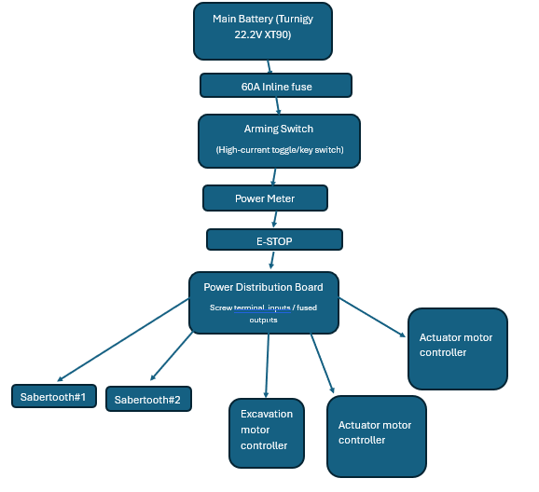
Figure 3 Power Domain Diagram

Compute Power Domain
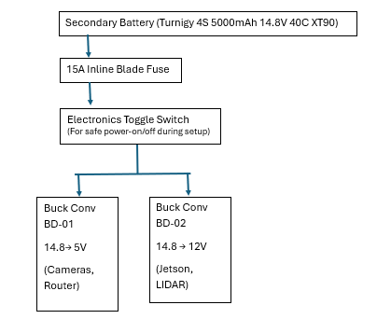
Figure 4 Compute Domain Diagram

Peak Current Calculations
Using the datasheets: find the peak current for the component for example the GR-WM4-V3 the datasheet states:
- Stall current at 22.2V: ~22.6A
- Current at peak gearbox torque: 13A
- Apply the data sheets 10% safety factor: 13A x 1.10 = 14.3A
The peak current can also be calculated from the power – use: I = P ÷ V . For example the router at 5V, max 15W: I = 15 ÷ 5 which equals = 3.0A.
Circuit/Wiring ID’s: PT = Power Trunk, MC = Motor controllers, MT = Motor terminal, BC = Buck Converters, LP = Low Power, ENC = Encoders.

Component Connection Map

Main Battery → ANL Fuse → Arming Switch → Power Meter → E-STOP → PDB

Circuit ID | From | To | AWG | Fuse | Connector/Notes
PW-01 | Main Battery + | ANL Fuse IN | 10 AWG | 40A ANL | XT90 anti-spark at battery. Red wire.
PW-02 | ANL Fuse OUT | Arming Switch L1 | 10 AWG |  | Ring terminals on switch lugs. Red wire.
PW-03 | Arming Switch L2 | Power Meter +IN | 10 AWG |  | High-current ring terminal on E-STOP stud.
PW-04 | Power Meter +OUT | E-STOP Terminal A | 10 AWG |  | High-current ring terminal onto E-STOP input lug.
PW-05 | E-STOP Terminal B | PDB +IN | 10 AWG |  | Wire into PDB positive rail.
PW-GND | Main Battery - | PDB -IN | 10 AWG |  | Black wire. Ground does NOT pass through E-STOP.

Power wiring – PDB to Sabertooth
Circuit ID | From | To | AWG | Fuse | Notes
MC-01 + | PDB + rail | Sabertooth #1 B+ | 10 AWG | None | Fuse within 50mm of PDB output. Ring terminal
MC-01 - | PDB – rail | Sabertooth #1 B- | 10 AWG |  | Black wire to Sabertooth B- terminal
MC-02 + | PDB + rail | Sabertooth #2 B+ | 10 AWG | None | PDB 15A fuse → DollaTek 300W buck (22.2V→12V) → Cytron #2 VPWR. 250mm actuators rated 12V.
MC-02 - | PDB – rail | Sabertooth #2 B- | 10 AWG |  | Black wire

Signal wiring – Sabertooth to Jetson
Using Simplified Serial (one wire per controller). Set DIP switches on Sabertooth to Serial mode.
Signal | Sabertooth Pin | Connects To | AWG | Notes
S1  (Serial) | S1 terminal | Teensy 4.1 UART TX | 24 AWG | Single-wire simplified serial. 9600 baud default
0V  (Ground) | 0V terminal | Common GND Bus | 24 AWG | MUST share ground with Jetson. Essential for signal reference
5V OUT | 5V terminal | Do NOT connect |  | Sabertooth can supply 5V but use your BC-02 instead for cleaner power

Motor Wiring – Sabertooth to GR-WM4-V3 motors
Circuit ID | From | To | AWG | Connector/Notes
MT-01 | Sabertooth #1  M1A/M1B | Drive Motor 1 +/- | 14 AWG | Screw terminal on Sabertooth → bullet connector of GR-WM4 6P latch connector
MT-02 | Sabertooth #1  M2A/M2B | Drive Motor 2 +/- | 14 AWG | Same as MT-01
MT-03 | Sabertooth #2 | Drive Motor 3 +/- | 14 AWG | Same as MT-01
MT-04 | Sabertooth #2 | Drive Motor 4 +/- | 14 AWG | Same as MT-01

Encoder Wiring – GR-QM4-V3 to Jetson
Wire | Colour | Connects to | AWG | Notes
VCC | Red | Teensy 4.1 3.3V | 26AWG | 5V encoder power. <10mA. Can use WAGO 221-413 to share supply
GND | Black | Common GND bus | 26 AWG | Share ground with Teensy
CH A | Blue | Jetson GPIO input | 26 AWG | Twist CH A and CH B together. Route away from 14 AWG motor wires
CH B | Yellow | Jetson GPIO | 26 AWG | Quadrature pair with CH A

Power Wiring – PDB to Cytron
Circuit ID | From | To | AWG | Fuse | Notes
ACT-01 + | PDB + rail | Cytron #1 B+ | 10 AWG | 15A Inline | Fuse within 50mm of PDB output. Ring terminal
ACT-01 - | PDB – rail | Cytron #1 B- | 10 AWG |  | Black wire to Cytron B- terminal
ACT-02 + | PDB + rail | Cytron #2 B+ | 10 AWG | 15A Inline | PDB 15A fuse → DollaTek 300W buck (22.2V→12V) → Cytron #2 VPWR. 250mm actuators rated 12V.
ACT-02 - | PDB – rail | Cytron #2 B- | 10 AWG |  | Black wire

Signal Wiring - Cytron to Jetson
Signal | Cytron Pin | Connects To | AWG | Notes
PWM 1 | PWM1 Pin | Teensy 4.1 PWM | 24 AWG | Teensy 4.1 native PWM. PCA9685 I2C expander removed — Teensy has 31 native PWM pins.
DIR 1 | DIR1 Pin | Teensy 4.1 GPIO | 24 AWG | Standard 3.3V logic. Teensy GPIO: Pin 9/10 for Cytron #1, Pin 11/12 for Cytron #2.
PWM 2 | PWM2 Pin | Teensy 4.1 PWM | 24 AWG | Teensy 4.1 native PWM. PCA9685 I2C expander removed — Teensy has 31 native PWM pins.
DIR 2 | DIR2 Pin | Teensy 4.1 GPIO | 24 AWG | Standard 3.3V logic. Teensy GPIO: Pin 9/10 for Cytron #1, Pin 11/12 for Cytron #2.
GND | GND Pin | Common GND Bus | 24 AWG | MUST share ground with Teensy 4.1.

Actuator Wiring – Cytron to Actuator
Circuit ID | From | To | AWG | Connector/Notes
ACT-M-01 | Cytron #1  M1A/M1B | TRU 50mm Actuator 1 +/- (Brown+/Blue-) | 14 AWG | TRU Components 50mm. Cytron #1 M1, 22.2V direct. Brown(+)/Blue(-). 1.6A peak. Polarity reverses for extend/retract.
ACT-M-02 | Cytron #1  M2A/M2B | TRU 50mm Actuator 2 +/- (Brown+/Blue-) | 14 AWG | Same as MT-01
ACT-M-03 | Cytron #2 | DCHOUSE 250mm Actuator 3 +/- (Red+/Black-) | 14 AWG | Same as MT-01
ACT-M-04 | Cytron #2 | DCHOUSE 250mm Actuator 4 +/- (Red+/Black-) | 14 AWG | Same as MT-01

Power Wiring – PDB to BLD-510B BLDC Controller
Circuit ID | From | To | AWG | Fuse | Notes
EXC-PWR + | PDB + rail | BLDC VCC (B+) | 16 AWG | 10A Blade | Main 22.2V power for excavation. Screw terminal.
EXC-PWR - | PDB - rail | BLDC GND (B-) | 16 AWG |  | Ground return. Screw terminal.

Signal Wiring – BLD-510B BLDC to Jetson
Signal | Cytron Pin | Connects To | AWG | Notes
EXC-SIG-VR | VR (Speed) | Teensy Pin 6 | 24 AWG | Teensy Pin 6 PWM → 10kΩ + 10µF RC filter → BLD-510B SV pin. Converts PWM to 0–5V analog for speed control.
EXC-SIG-DIR | Z/F (Direction) | Teensy Pin 13 | 24 AWG | Teensy Pin 13 GPIO. F/R direction on BLD-510B.
EXC-SIG-GND | GND | Common GND Bus | 24 AWG | Logic ground reference. MUST connect to Jetson ground.

Excavation Motor Wiring – BLDC to Excavation Motor
Circuit ID | From | To | AWG | Connector/Notes
EXC-MOT-U | BLDC U | Phase U (Orange) | 18 AWG | 4mm Bullet. Match to motor's ORG wire.
EXC-MOT-V | BLDC V | Phase V (Green) | 18 AWG | 4mm Bullet. Match to motor's GRN wire.
EXC-MOT-W | BLDC W | Phase W (Brown) | 18 AWG | 4mm Bullet. Match to motor's BRW wire.
EXC-HALL-5V | BLDC 5V | Hall 5V (Red) | 26 AWG | Powers internal sensors.
EXC-HALL-GND | BLDC GND | Hall GND (Black) | 26 AWG | Sensor ground.
EXC-HALL-A | BLDC Ha | Hall A (Yellow) | 26 AWG | Position feedback wire A.
EXC-HALL-B | BLDC Hb | Hall B (White) | 26 AWG | Position feedback wire B.
EXC-HALL-C | BLDC Hc | Hall C (Blue) | 26 AWG | Position feedback wire C.

Complete Wiring Gauge
ID | Circuit | Peak I (A) | +10% | =0.8 Req. | AWG | Capacity | Fuse | Connector
PT-01-05 | Batt trunk (all) | 40 | 44 | 55A | 6 | 75A | 40A ANL | XT90
MC-01 +/- | PDB → Sabertooth #1 | 26 | 28.6 | 35.8A | 10 | 40A | 40A blade | Screw
MC-02 +/- | PDB → Sabertooth #2 | 26 | 28.6 | 35.8A | 10 | 40A | 40A blade | Screw
EX- 01+/- | PDB → RoboClaw |  |  |  | 14 | 20A | 20A blade | Screw
MT-01-04 | Sabertooth → Drv Motor | 13 | 14.3 | 17.9 | 14 | 20A |  | Bullet/6P
EX-02 | RoboClaw → Exc Motor |  |  |  | 14 | 20A |  | Bullet/Lug
BC01-IN | PDB → Buck 12V | 16 | 17.6 | 22A | 18 | 10A | 20A blade | Solder pads
BC02- IN | PDB → Buck 5V | 2.5 | 2.75 | 3.4A | 20 | 7.5A | 5A blade | Solder pads
ACT- 01-04 | Buck 12V → Actuators | 4 ea | 4.4 | 5.5A | 20 | 7.5A |  | WAGO 221-415
LP-LDR | BD-01 12V → LiDAR | 0.5 | 0.55 | 0.69A | 22 | 5A |  | WAGO/GH1.25
LP-CAM | 5V bus →OAK-D | 0.9 | 1.0 | 1.25A | 22 | 5A |  | USB-C
LP-IMU | 5V bus → IMU | 0.1 | 0.11 | 0.14A | 24 | 3.5A |  | WAGO/UART
ENC-01-04 | 5V bus → Encoders x4 | 0.01 ea | 0.011 | 0.014A | 26 | 2.5A |  | XT30/XT60
SEC-01 | Sec Batt → BD-01/02 | 3 | 3.3 | 4.1A | 18 | 10A | 10A blade | XT30/  XT60
BD01-OUT | Buck 12V → Jetson + LiDAR | 1.3 | 1.43 | 1.8A | 20 | 7.5A |  | Barrel 5.5/2.1
BD02-OUT | Buck 5V → Router | 3 | 3.3 | 4.1A | 20 | 7.5A |  | USB-C
SIG-xx | Jetson → Controllers | <0.50 |  |  | 24 | 3.5A |  | Dupont.JST

Power budget
The rover uses a dual-source power architecture to separate the drivetrain and excavation subsystems from the computational subsystem. To prevent massive current spikes and thermal damage, drivetrain and excavation subsystem enforces a mutually exclusive operational rule that the excavation arm must never run while the drivetrain is active.

Drivetrain and excavation subsystem:
The absolute maximum load is dictated by which part of the subsystem is be used:

Scenario A: Driving & Navigating
In this scenario 4 drivetrain motors (GR-WM4-V3) would be utilised with each of them having a rated current of 3.8A, having a theoretical nominal current draw of 15.2A. The max current draw that the motor can reach is 22.6A according to the datasheet however at 13A the internal gearbox will break and therefore the Sabertooth 2x32 current limiting is configured in software to 10A per channel to enforce this gearbox limit. This means that the max theoretical current draw that the drivetrain will produce is 40A.

Scenario B: Excavation (Rover is stationary)
In this scenario, 1 excavation motor (57BLR50-24-01-HG100) and 4 actuators would be utilised. The excavation motor has a rated current of 5.0A, and the actuators have a combined nominal current draw of approximately 6.4A, resulting in a theoretical nominal current draw of 11.4A. To protect the hardware, the excavation BLDC controller is protected by a 10A fuse, and the actuator motor controllers (Cytrons) are protected by their own 15A fuses. This ensures that while the nominal draw is low, the maximum theoretical current draw the entire excavation subsystem can pull during a severe mechanical jam is strictly physically capped at 40A before the local fuses blow.

Computational subsystem:
The computation domain is supplied by a secondary 14.8V LiPo battery. This power is stepped down to 12V for the Jetson and stepped down to 5V for the sensors, fully isolated from any 40A motor spikes.
Component | Max Power draw (W) | Current draw (A)
Jetson | 25 | 2.25 (Max 3)
Cameras | 12.5 x 2 | 1.13 (Max 2) x 2
Router | 6.5 | 0.59 (Max 1)
LiDar | 6.0 | 0.54 (Max 2)
Total | 50 | ~6A (Max 10)

Battery C-Rating Numerical Justification
The primary battery selected for the actuation domain is the Turnigy 8000mAh 6S LiPo with a 15C discharge rating.
Battery Capacity (C): 8000mAh = 8Ah.
Rated Constant Discharge: 8Ah * 15C = 120A.
Absolute Peak System Demand: 40A (Drivetrain capped).
The Safety Factor (SF) for the battery's discharge capability is calculated as:
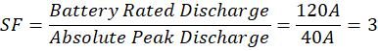
With Sabertooth software current limiting enforced (10A per channel), the motive battery comfortably supplies the capped peak demand with a 3× safety factor. The LiPo cells will experience virtually zero thermal stress or voltage sag.

Secondary Compute Battery (14.8V) C-Rating Justification
The secondary battery powering the autonomy and sensor stack is an 14.8V 5000mAh 4S LiPo with a 40C discharge rating.
Battery Capacity (C): 5000mAh = 5Ah.
Rated Constant Discharge: 5Ah * 40C = 200A.
Absolute Peak System Demand: 12A (BD-01 rail ~6A + BD-02 rail ~6A)
This gives a SF of:
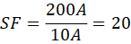
The secondary battery is vastly over-specked for current delivery, capable of outputting nearly 20 times the maximum required amperage of the compute domain. This massive headroom is intentionally designed to guarantee absolute voltage stability (zero voltage sag) for the sensitive NVIDIA Jetson and onboard sensors, completely isolating them from the extreme 40A transients occurring on the mechanical actuation rail.

Battery Runtime Calculation
Runtime is calculated using the highest continuous load profile (driving) and a safe discharge limit of 80% to protect the lithium cells.
Primary Actuation Battery (Turnigy 8000mAh / 8Ah):
Usable Capacity (80%): 8Ah *0.8 = 6.4Ah
Average Continuous Load: 15.2A
Runtime Calculation: (6.4Ah/15.2A) *60 minutes = 25.3 minutes
Secondary Compute Battery (Turningy 5000mAh / 5Ah):
Usable Capacity (80%): 5Ah * 0.8 = 4Ah
Continuous Compute Load: 6A
Runtime Calculation: (4Ah / 6A) *60 minutes = 40 minutes

Physical integration

Overview
This report summarises the design, packaging, and thermal considerations for the rover’s electrical enclosure. The objective of the enclosure design is to ensure safe power distribution, adequate thermal management, and maintainability while integrating electrical components within the mechanical constraints of the robot chassis.
The electrical box houses the primary computing unit, motor drive controllers, batteries, power distribution boards (PDBs), and supporting electronics. The design has been validated through CAD integration with the mechanical team to ensure correct mounting, airflow management, and serviceability.

Electrical Layout Architecture
The enclosure follows a single-direction airflow layout to optimise cooling and minimise thermal interaction between sensitive electronics and high-power components.
Component zoning:
Cool Zone (Air Intake Region)
- Jetson Orin Nano (primary compute)
- Low-voltage electronics
- Power distribution board
Neutral Zone (Central Region):
- 22.2 V battery
- 14.8 V battery
- Batteries mechanically secured on the polycarbonate base plate
Hot Zone (Air Exhaust Region)
- 5 Motor Drivers
  - 2 motor controllers for drive train
  - 1 excavation motor controller
  - 2 motor controllers for actuators
- High-power PDB distributing power to motor drivers
This arrangement ensures the hardware receives the coolest incoming air, while the highest heat-generating components are located near the exhaust vents.

Mechanical Packaging
The enclosure baseplate is constructed from 5mm polycarbonate, which serves as both the structural mounting surface and a passive heat spreader for power electronics.
Mounting strategy:
Component: | Mounting Method:
Jetson Orin Nano | 10–20 mm standoffs
Motor Drivers | 10–15 mm standoffs
Power Distribution Boards | 8–12 mm standoffs
Batteries | Mechanically strapped

Clearance beneath PCBs allows:
- airflow circulation
- solder joint protection
- cable routing

Component Weight Summary: Electrical box contents (batteries, compute, motor drivers, wiring) ≈ 3.2 kg. Total electrical system including all external components (LiDAR, router, cameras, actuators ×4, drivetrain motors ×4, excavation motor) ≈ 9.4 kg. Motor and actuator values are estimated and should be replaced with measured figures once hardware arrives.

Thermal Management Strategy
The enclosure utilises active airflow cooling the system relies entirely on the standoffs and active airflow for cooling.
Cooling system features:
- Filtered intake vents to reduce dust ingress in the competition environment.
- Cooling fans to maintain positive airflow.
- Exhaust vents positioned near motor drivers.
- Polycarbonate baseplate for strength.
Airflow path:
Filtered Intake → Jetson & Low Power Electronics → Battery Region → Motor Drivers → Exhaust
This layout prevents heat generated by motor drivers from recirculating toward sensitive computer hardware.

Electrical Safety Considerations
The electrical system incorporates several safety measures:
- Separate batteries for compute and drive systems
- Dedicated power distribution boards
- Battery mounting with insulation and mechanical retention
- Short high-current cable routing between batteries and PDBs
This configuration improves reliability and simplifies fault isolation during operation.

CAD Integration & System Validation
The electrical box layout has been integrated with the mechanical team’s CAD assembly to confirm:
- All components are mounted correctly
- Cooling airflow paths are unobstructed
- No packaging conflicts exist
- Serviceability and maintenance access are maintained

Evidence
- Electrical box layout developed and validated in CAD
- Cooling strategy reviewed with mechanical team
- Final packaging design confirmed for component clearance and airflow

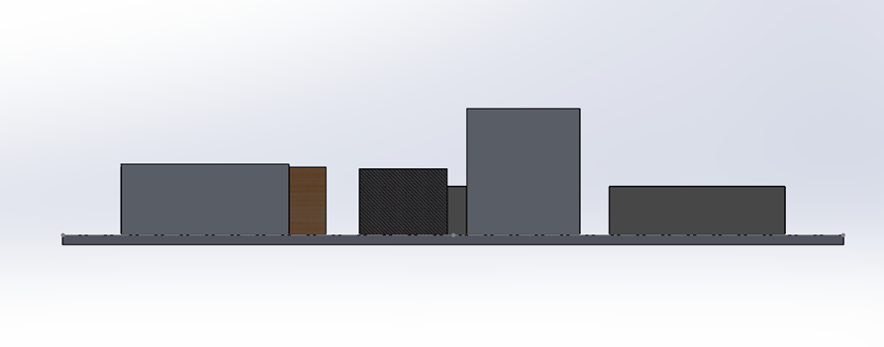
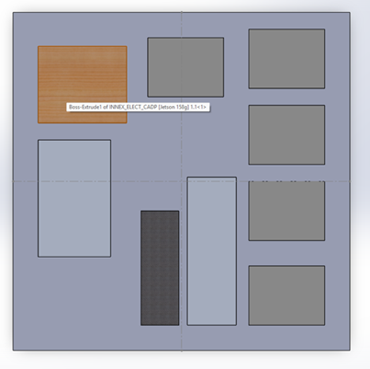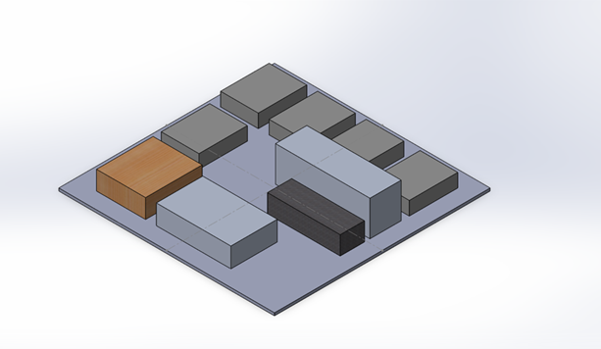
Figure 5 CAD Files for Electrical Box
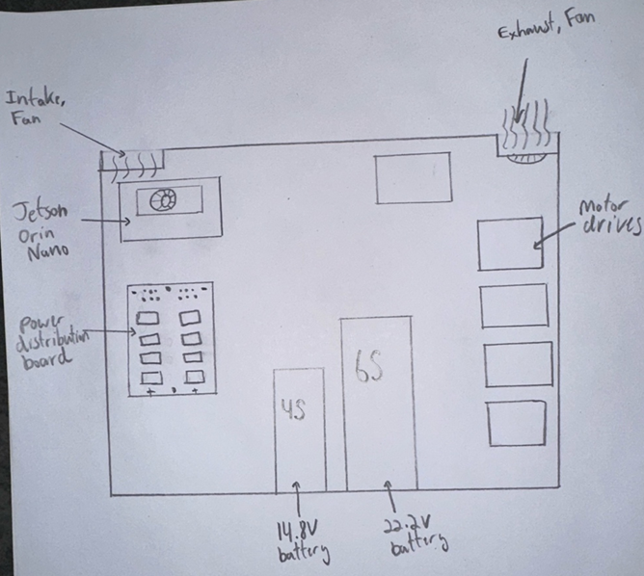
Figure 6 Exhaust and Cooling Diagram

E-STOP & safety chain

Back EMF
As relating to safety, it can be considered that back EMF can result in potential hazards, as some components are not designed to handle them. To analyse and eliminate threats, the diagram must be understood. There are 2 voltage sources one on the far left and one on the far right. The far left (main battery) provides 22.2V handled by a 8,000 mAh and the far right (secondary battery) provides 14.8V.
The heavy lifting is carried out by the main battery, as it provides a greater amperage required for high torque applications with the motors and servos, covering majority of the mechanical motion. The secondary battery handles all input and processing power and is smoothened by the power distribution board. All power links go into the Jetson which then powers the other sensors. At no point does the powering of the main battery and the secondary battery intersect, and only signal wires are present to provide data via PWM pins.
The PDB listed between the secondary battery and the Jetson Orion nano, does not handle back EMF, but is not required to do so, as the Jetson has no physical component to allows back flow. The other sensors connected cannot cause back flow either.
The servos and motors have potential cause for backflow, provided a slippage occurs when the rover is stationary, and the motors could provide a generator effect. In order to handle these motors, the drivers selected have their own unique features. 2 of the 3 have regenerative braking, designed to handle backflow and use braking to regenerate power. The cheaper option does not have regenerative braking but has basic protection enough to handle back EMF in this situation. Additionally, diodes can be introduced with resistors in place to handle excessive current spikes.
In conclusion, there is potential for back flow to occur, but is handled and additional support can be provided if testing does not go according as expected.

Bench Test
As we do not have the physical components with us right now, a bench test can be confirmed by utilizing sources to showcase something of similar insight has been before and justified about how it a predictable outcome will arise.
Hardware Component Overview — FIRST Robotics Competition documentation
The link above showcases the basics circuits used in FRC (FIRST robotics competition). The battery is connected to a 120A main breaker, ideally this would be a relay switch, where a smaller current is handled by a switch which in turn cuts off a high current line. The flow diagram showcased has its battery connected in parallel, and there is no voltage leaks between either battery listed. A single E-stop will be placed exclusively on the 22.2V power domain. When triggered, it instantly severs all power to the actuators and drivetrain, while leaving the independent 14.8V compute battery untouched. This ensures the Jetson and router safely stay powered on, so telemetry and video feeds are not lost during a safety stop.

E-stop requirements
The E-stop selected for INNEX-1 is a Heavy-duty DC emergency stop switch — 250 A @ 80 V DC, push-break/pull-make, M8 copper posts, IP50, 10,000 cycle life. Meets competition requirements for a latching push-to-stop switch.
The rule book says the button must be an unmodified commercial off the shelf red button and must have minimum diameter of 40mm.
It must disable power with a single push motion and latch in a stop position until it is intentionally undone via a twist or pull action.
While a mechanical relay (contactor) circuit is permitted, utilizing a direct high-current disconnect switch like the ADK 125A reduces wiring complexity, eliminates the risk of relay-coil failure, and provides a more robust physical break in the 22.2V circuit.
To comply with competition safety standards, the E-stop will be wired as the first component in-line immediately following the battery's main positive terminal, completely isolating the power distribution board when pressed.
So, the following buttons are viable that follow these rules:
Main Choice: Heavy-duty DC emergency stop — 250 A @ 80 V DC (installed) – quote requested
Alternative Choice: ED125-4 | Albright 125A at 48V Battery Isolator Stop Switch – quote requested

E-Stop Schematic
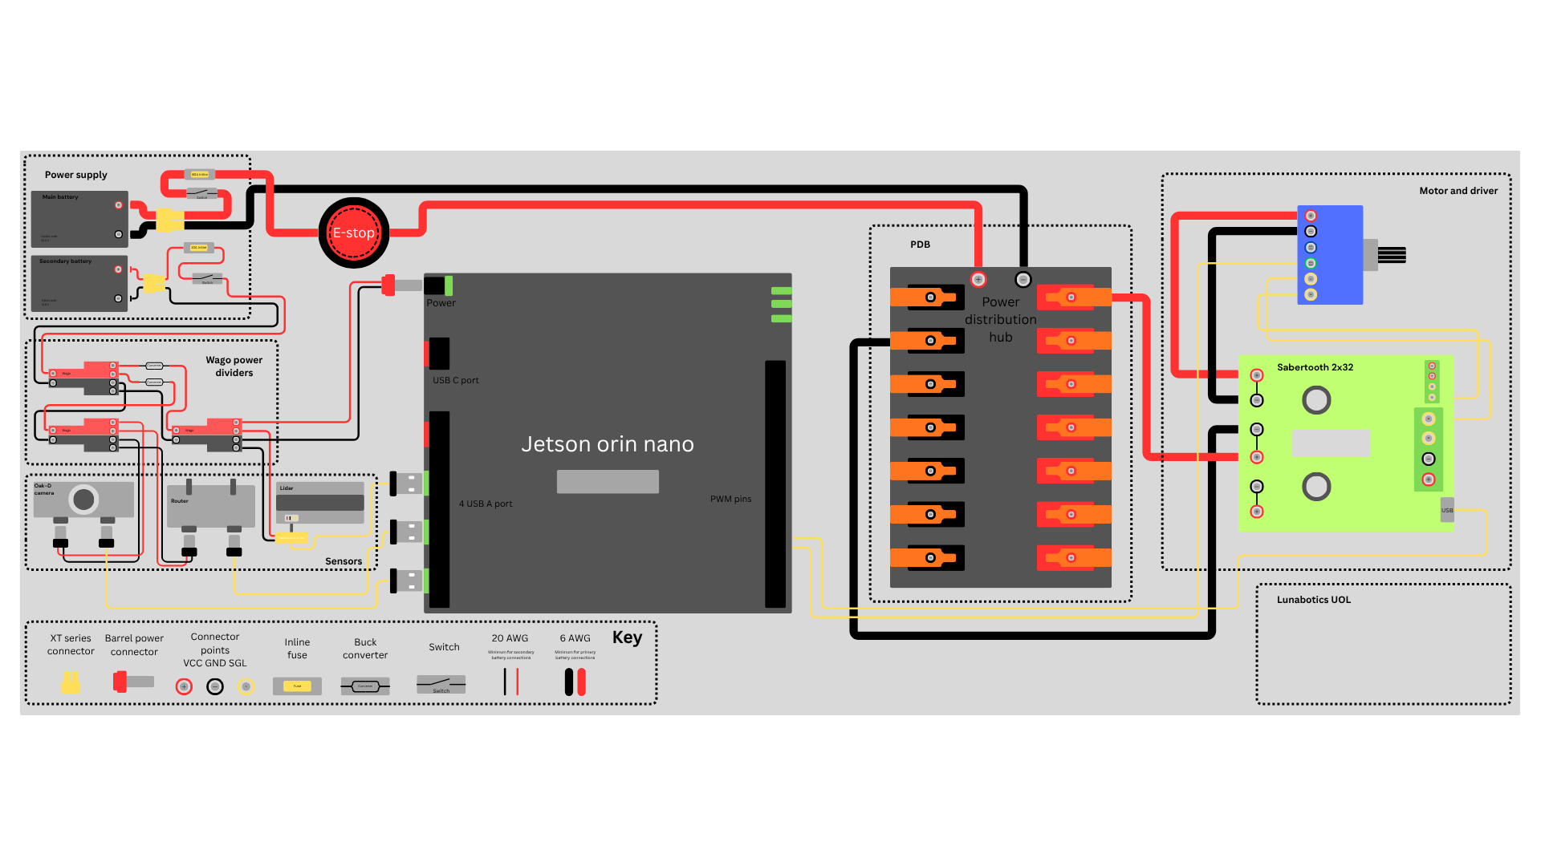
Figure 7 E- Stop and Wiring Schematic

Procurement locked

Main parts BOM
No# | Component name | QTY. | Price | Notes | Sub-system | Companies/Suppliers | Shipping Fees | Delivery
1 | Cameras | 2 | £301 |  | Sensors | Luxonis | DHL £15 | 2-5 days DHL
2 | Main battery | 1 | £68.3 |  | Power Systems | Turnigy | £11.37 | 3-7 Days, Free Delivery if we get both batteries
3 | Secondary battery | 1 | £34.28 |  | Power Systems | Turnigy | £6.72 | 3-7 Days, Free Delivery if we get both batteries
4 | Drivetrain motor (GR-WM4-V3) | 4 | £75.5 |  | Power Systems | GimsonRobotics | None | Secured via direct supplier partnership (Awaiting dispatch)
5 | Excavation motor | 1 | £46.79 |  | Power Systems | StepperOnline | £18.14 | £26.74; 4-10 working days.
6 | Voltage regulator 1 | 1 | £3.22 |  | Power Systems | Switch Electronics | None | £3; 2-3 working days
7 | Voltage regulator 2 | 1 | £7.77 |  | Power Systems | Amazon | None | 2-3 days
8 | Actuators | 4 | £67.75 |  | Power system | TRU COMPONENTS | £45.17 | 50mm TRU ×2 (22V, Cytron #1) + 250mm DCHOUSE ×2 (12V, Cytron #2). No fees, 4 days
9 | Power Distribution Board | 1 | £31.28 |  | Power Systems | Amazon | None | 1 week
10 | Microcontroller | 1 | £280.6 | NVIDIA Jetson Orin Nano Super Developer Kit | Control Systems | RS | None | Free, 2-3 working days
11 | Sabertooth Motor controllers | 2 | £114.1 | 2 for drivetrain | Control Systems | Robotshop | None | £25.59 (Free if we get Cytrons); 2-7 working days
12 | Cytron Motor Controllers | 2 | £20.03 | 2 for actuators | Control Systems | Robotshop | None | £25.59 (Free if we get Sabertooths); 2-7 working days
13 | BLD-510B BLDC Motor Controller | 1 | £12.54 | 1 for excevation | Control Systems | Amazon | None | £0.79; 1-2 weeks
14 | Dual-band router | 1 | £55.24 |  | Communication System | Amazon | None | £5; 1 week

Cost
Total: £2,172.28
Electrical total: £1,552.29
Sponsorship (Luxonis): £376
Electrical total (after discount): £1,176.29
Shipping Fees Total: £96.4
Shipping Fees Electrical: £33.09
Delivery Fees Total: £35.53
Delivery Fees Electrical: £9
Total (including shipping and delivery): £1927.16
Total Electrical (including shipping and delivery): £1218.38 (without LiDAR: £1029.58)

Alternative List
Sub-system | Primary Component | Alternative Component | Alternative Cost | Trade-off / Justification
Control Systems | NVIDIA Jetson Orin Nano | Raspberry Pi 5 (8GB) | £80.00 | If the Jetson fails or faces supply chain issues, the RPi 5 is a viable backup. Loss of onboard CUDA cores. However, because we utilize Luxonis OAK-D cameras, the RPi 5 has enough CPU overhead to successfully run Nav2 and our ROS 2 partial autonomy.
Control Systems | Sabertooth Dual Motor Controller | RoboClaw 2x60A | £125.00 | Direct competitor to Sabertooth. Slightly higher cost but offers dual-channel DC motor control with built-in USB/Serial ROS 2 compatibility and thermal protection for the 22.2V power domain.
Control Systems | Cytron Motor Controllers | BTS7960 43A Motor Driver | £10.00 | Backup for the linear actuators. Very cheap driver but lacks the logic-level protection of the Cytron. Requires slightly more complex logic from the Jetson to prevent short circuits.
Power Systems | 250A DC E-Stop Switch (push-break, 80V, M8 posts) | Albright ED125-4 | £45.00 | The Albright is the gold standard for heavy industrial battery isolation. Higher cost and longer lead time than the ADK but guarantees the same 125A breaking capacity to safely break a 60A DC rail without problem.
Communication | Slate Plus Dual-Band Router | GL.iNet Beryl AX (GL-MT3000) | £75.00 | Available on Amazon. Higher cost but provides Wi-Fi 6 bandwidth to easily keep our compressed telemetry data under the rulebook's 4,000 Kbps limit.
Sensors | Ouster OS1 LiDAR | Livox Mid-360 | £550.00 | The industry standard for 3D SLAM on robots. Provides dense 360-degree point clouds fully capable of mapping negative obstacles (craters) in the lunar simulant. Drastically higher cost. The Ouster OS1 was uniquely selected for its sub-£200 price point. Implementing the Livox backup would instantly break the budget cap, requiring a budget extension or an external LiDAR sponsorship.

